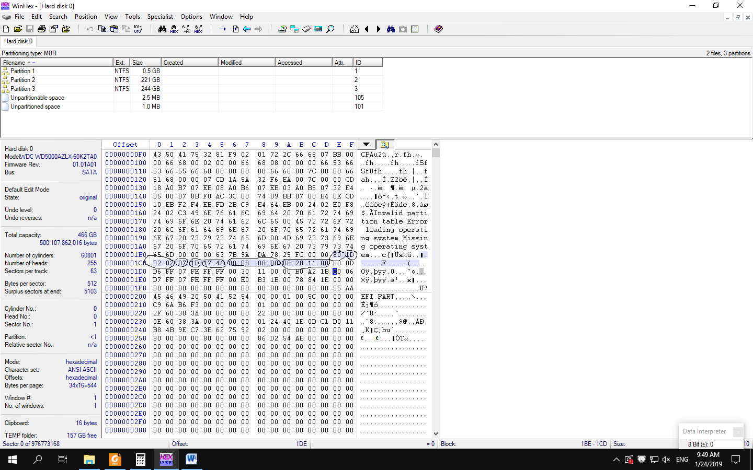

6417 h = 100011000 010111 B

100011000 010111

Cylinder Sector

280 23